YIPYY · PRODUCT & ENGINEERING
Yipyy Calling
Remediation & Build Workflow

Purpose Turn the existing calling prototype into a shipped, own-branded product: remove all carrier branding from the facility experience, consolidate a split settings surface, replace simulated call state with real telephony, and reconcile contradictory analytics.

Field | Value
Document | Yipyy Calling — Remediation & Build Workflow
Version | v1.0 — Draft for approval
Date | 22 August 2026
Owner | Product / Engineering
Scope | Facility-portal telephony: branding, information architecture, settings, call experience wiring, data integrity, rollout
Inputs | Yipyy facility portal walkthrough (14 screens) · MoeGo Calling (Beta) help centre: Overview, Setup, Inbound/Outbound, Review Activity, Troubleshooting
Status | Awaiting Phase 0 decisions

Contents

1. Executive summary
Yipyy Calling is further along than a first look suggests. The facility portal already contains an IVR builder with preview, CRM-driven smart routing rules, a live call queue with position and wait estimates, staff presence with auto-reset, QA scoring with a flagged-review queue, call tagging, recording with transcription, voicemail with AI summaries, and — confirmed in the latest walkthrough — a full inbound screen-pop and an in-call panel with pet context, outstanding balance, VIP flags, call notes, live tagging, and mute / hold / keypad / transfer controls.
On feature surface area, this is ahead of MoeGo, the closest comparable product in pet-care software. MoeGo has no IVR builder, no routing rules, no queue, no presence, and no QA layer.
The problem is not capability. It is that the product currently reads as a prototype wearing someone else's name:
- It is branded as a vendor integration. Settings → Integrations shows facilities "Twilio SMS", "Twilio VOIP" and "SendGrid Email" as connectable services, with toggles that let a facility disconnect its own phone line.
- The call experience is driven by simulation. The screen-pop and active-call panel are reached through "Simulate Known Caller" / "Simulate Unknown Caller" buttons that ship in the facility UI, and the in-call timer reads 99:23 — a placeholder, not elapsed time.
- The numbers contradict each other. The Analytics tab carries two unrelated sections: one reporting 0 calls from the live call log, one reporting 26 calls, a 31% answer rate and $600 of attributed revenue from mock data.
The work ahead is therefore mostly wiring, consolidation and naming — not net-new feature construction. That is a much shorter path to a sellable product than the feature list implies, and it is the reason this plan front-loads credibility work in Sprint 1 and treats the remaining CRM actions as a fast follow.

The one-line thesis
Yipyy has built more calling product than its closest competitor and is presenting it as a Twilio integration. Rename it, wire it to real calls, make the numbers agree — then sell it.

2. What is already built in Yipyy
This section is the inventory the plan is built on. Everything listed here exists in the portal today; the assessment of whether it is real or simulated is in section 4.

2.1 Module structure
Communication → Calling, with a KPI header (System Status, Missed, Voicemails, Today) and eight tabs: Live, Dialer, Call Log, Voicemail, Recordings, IVR & Routing, Analytics, Settings.

2.2 The call experience — confirmed built
Inbound calls surface a docked panel in the top-right of the portal. For a recognised number it resolves the client, their pet, upcoming appointment count and VIP status before the call is answered.
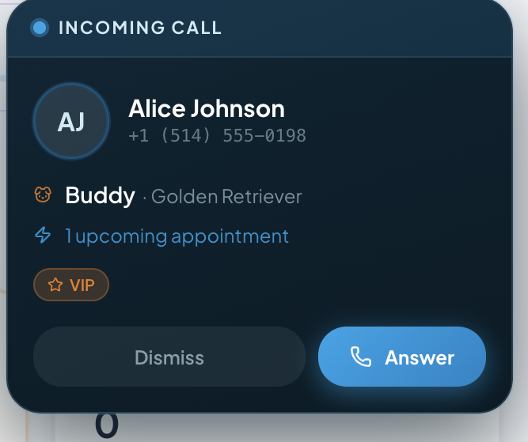
Figure 1 — Inbound screen-pop, recognised caller: client, pet and breed, upcoming appointment, VIP flag, Dismiss / Answer.
For an unrecognised number the panel collapses to a single decision, folding profile creation into the answer action rather than making it a separate step after the call. This is a better interaction than MoeGo's equivalent, which creates the profile as a consequence of answering rather than as a stated choice.
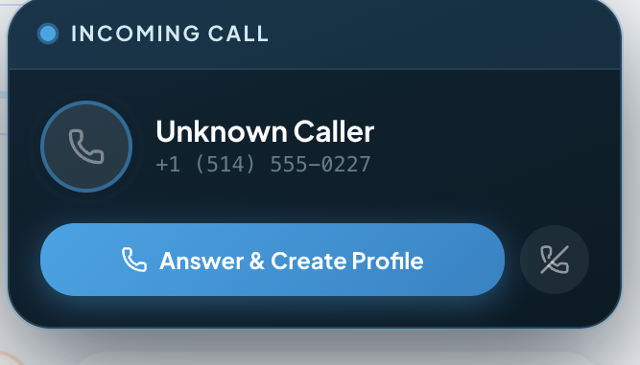
Figure 2 — Inbound screen-pop, unknown caller: "Answer & Create Profile" as the single primary action.
Once connected, the panel expands into a working surface: multiple pets with breeds, the active boarding stay, upcoming appointment count, outstanding balance, VIP and behavioural flags, a Create Booking action, a call-notes field, live call tagging, and the standard control set plus Add Staff to Call.
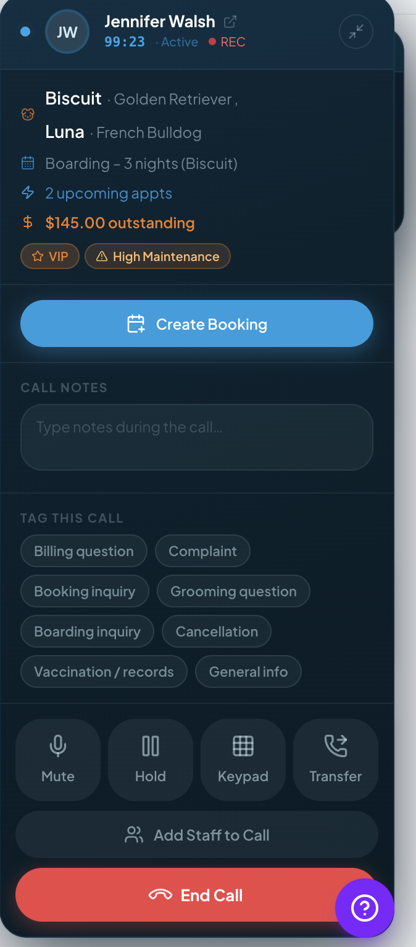
Figure 3 — Active call panel. Note the elapsed timer reading 99:23 (placeholder) and the support bubble overlapping the End Call control.

2.3 Live, routing, recordings and settings
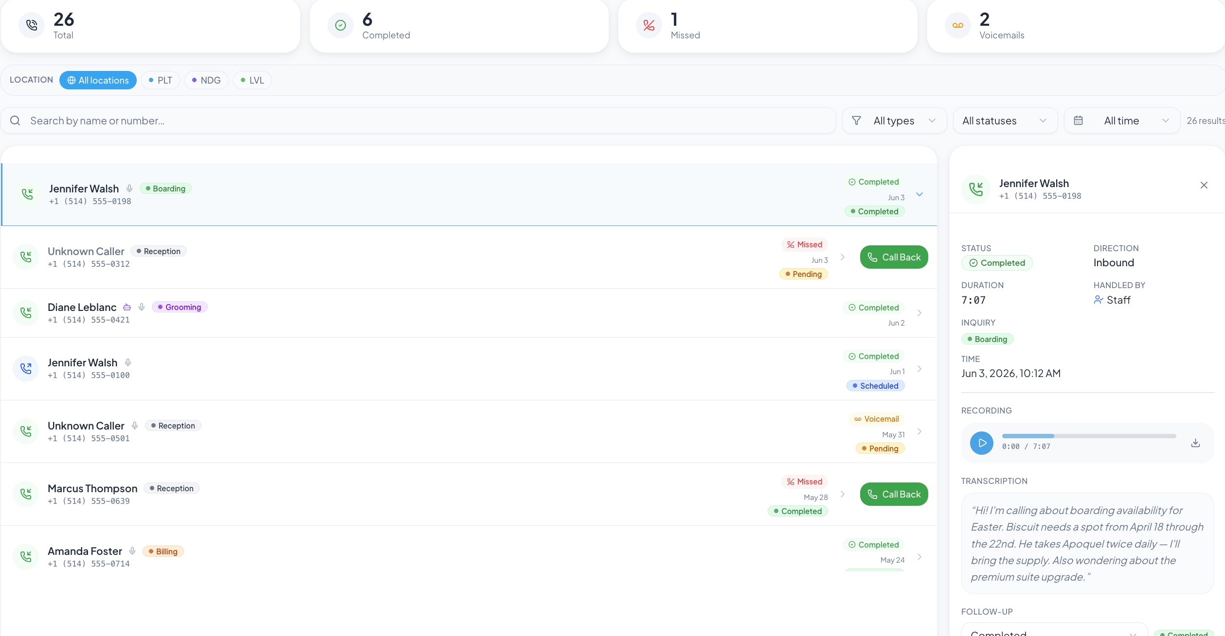
Figure 4 — Live tab: demo controls (to be removed), call queue with wait time and estimate, unanswered calls with auto-SMS confirmation and resolution state.
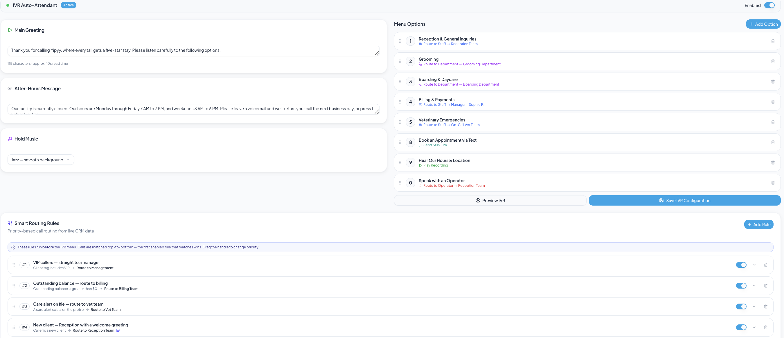
Figure 5 — IVR & Routing: auto-attendant with greeting read-time estimate, after-hours message, hold music, drag-ordered menu options, and priority-ordered smart routing rules that run before the IVR.
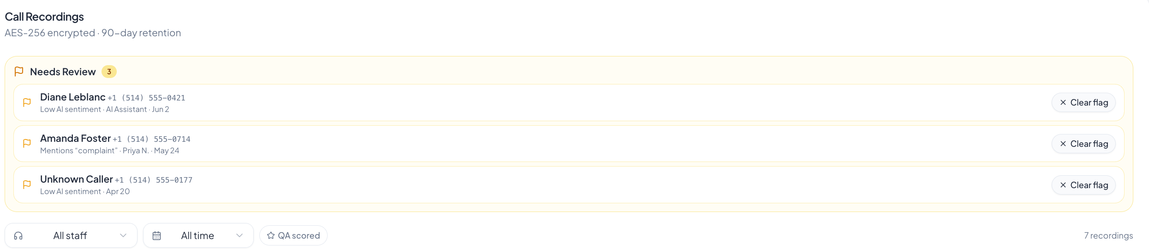
Figure 6 — Recordings: needs-review queue with flag reasons (low AI sentiment, keyword match) and QA scoring.
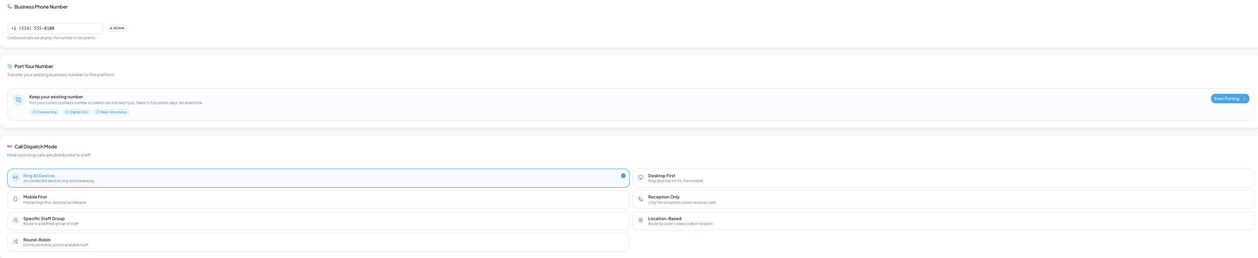
Figure 7 — Calling → Settings: business number, self-serve porting with digital LOA, and seven dispatch modes.
The Settings tab additionally carries call availability with ring-pool preview, call tags, queue position announcement, ring and alert preferences, call forwarding, ring duration, recording with transcription and retention, missed-call auto-SMS with template, business hours, and a staff permissions summary — all under a single Save Settings bar.

3. Where Yipyy is ahead of MoeGo
These are the differentiators. They should be protected through the remediation and used in positioning; none of them exist in MoeGo Calling today.
Capability | Why it matters commercially
IVR auto-attendant with preview | MoeGo routes to devices only. A menu lets a multi-service facility separate grooming, boarding, billing and vet emergencies without staffing a switchboard.
Smart routing rules from live CRM data | VIP → management, outstanding balance → billing, care alert → vet team, new client → reception. Routing on customer state, not just digits pressed. Nothing comparable exists in the category.
Call queue with position and wait estimate | Turns a busy signal into a managed wait. Directly reduces the abandoned-call number.
Staff presence with auto-reset | Busy / away without going offline, resetting automatically. Stops the ring pool degrading over a shift.
Round-robin and location-based dispatch | MoeGo offers five device-oriented modes; Yipyy adds fair distribution and geographic routing.
QA scoring and flagged-review queue | Low-sentiment and keyword-flagged calls surface for coaching. A management feature, not a phone feature — and a reason for owners to log in.
Call tagging with tag-frequency analytics | Turns call reasons into an operational signal (a spike in "complaint" is actionable).
Self-serve porting with digital LOA | MoeGo requires contacting a customer success manager. Yipyy can make this a signup-flow step.
Answer-on-one-device sync | Stops every device ringing after pickup — small, and the kind of detail that gets noticed daily.

4. The three problems

4.1 Problem one — the product is branded as someone else's
Settings → Integrations presents telephony and messaging to facilities as third-party connections, naming the carrier and the email provider, exposing an unformatted placeholder number, and offering toggles that can sever a live phone line.
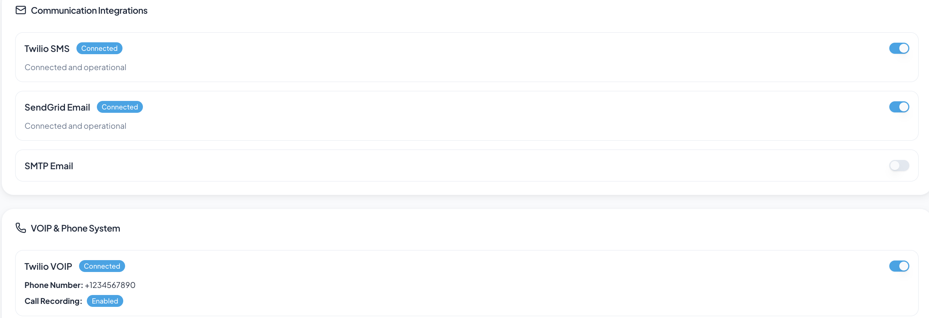
Figure 8 — Settings → Integrations today. Twilio SMS, Twilio VOIP and SendGrid Email are named to the facility; the VOIP card shows +1234567890 and a disconnect toggle.
MoeGo runs the same carrier and never says so. Across their entire published help centre, Twilio appears exactly twice: once in a troubleshooting footnote explaining that very short calls are skipped, and once in firewall documentation aimed at a facility's IT team. It never appears in the product. Their facilities buy "MoeGo Calling".
The underlying interface principle is not cosmetic: name things by what the person controls and recognises, never by how the system is built. A facility owner controls a phone number, a ring order and a voicemail greeting. They do not control a VOIP provider account, and showing them one creates three costs — avoidable support load, self-inflicted outages from the disconnect toggle, and a competitive tell that Yipyy is a thin wrapper around a commodity.

4.2 Problem two — the experience is a prototype shell
The call UI is built, but reached through simulation rather than through calls. Three tells are visible in the facility build:
- Demo controls ship in production. "Simulate Known Caller", "Simulate Unknown Caller" and "Show Active Call Panel" sit at the top of the Live tab.
- The in-call timer is a placeholder. It reads 99:23 rather than counting from answer.
- The number does not survive across screens. Integrations reports +1234567890 while Calling → Settings reports +1 (514) 555-0100 — there is no single normalised number, and no formatter shared between surfaces.
The consequence for planning is favourable: the expensive design and front-end work is done. What remains is a provider abstraction, a real call lifecycle, and binding the existing components to it.

4.3 Problem three — the numbers disagree with each other
The Analytics tab renders two independent sections, stacked, describing the same period.
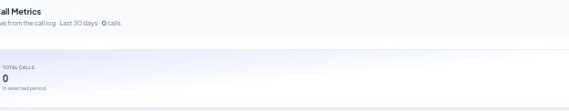
Figure 9 — Analytics, upper section: "Live from the call log · Last 30 days · 0 calls".
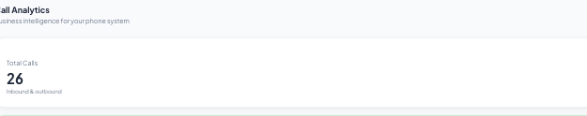
Figure 10 — Analytics, lower section on the same tab: 26 calls, 31% answer rate, 31% conversion.
A third account of the same data appears on the Call Log tab. The three do not reconcile:
Measure | Call Log tab | Analytics | Consequence
Total calls | 26 | 26 / 0 | Two aggregation paths, one of them mock
Missed | 1 | ≈18 (31% answer rate) | An 18× discrepancy on the metric the header KPI promotes
Completed | 6 | — | Not derivable from the answer rate shown
Revenue attributed | — | $600 | No attribution model exists behind the figure
Unanswered badge | 2 | — | Badge renders 2 while the list renders 3 rows
Why this is the highest-risk item
Feature gaps lose a deal. Numbers that contradict each other on one screen lose trust in every other number in the product — including occupancy, revenue and payroll. The $600 "Revenue from Calls" tile is the sharpest example: it is the figure an owner is most likely to challenge, and there is currently no model behind it.

5. Defect register
Twenty-two defects, graded. Blockers must clear before any facility outside the beta cohort sees the module.
ID | Defect | Severity
D-01 | Carrier and provider names exposed to facilities; disconnect toggle can sever live telephony | Blocker
D-02 | Calling configuration split between Integrations and Calling → Settings; two sources of truth for number and recording state | Blocker
D-03 | Number mismatch across screens (+1234567890 vs +1 (514) 555-0100); no E.164 normalisation or shared formatter | High
D-04 | Demo controls ("Simulate Known / Unknown Caller", "Show Active Call Panel") present in the facility build | Blocker
D-05 | Two contradictory analytics sections on one tab (0 calls live vs 26 calls mock) | Blocker
D-06 | Metric definitions unreconciled across Call Log, header KPIs and Analytics | High
D-07 | Badge counts computed separately from lists (Unanswered "2" over 3 rows) | High
D-08 | Three locations (PLT / NDG / LVL) share one number, one greeting, one set of business hours | High
D-09 | Recording retention stated twice — plan-derived chip vs hardcoded header | Medium
D-10 | Recording consent is a single global toggle; demo number is a 514 (Quebec) area code — two-party consent and Law 25 territory | Blocker (legal)
D-11 | Screen-pop and active-call panel are driven by simulation, not by call lifecycle events | Blocker
D-12 | No click-to-call entry points from Customer, Bookings, Estimates, Inbox, Daily Care or Booking Requests | High
D-13 | No mobile parity, no microphone/notification preflight, no diagnostics | High
D-14 | AI summaries exist on voicemail only; no save-to-client-note, feedback, or version history | Medium
D-15 | "Revenue from Calls" and "Conversion Rate" displayed with no attribution model | Blocker
D-16 | Staff permissions rendered in Calling Settings but owned by Roles; ownership ambiguous | Medium
D-17 | No stated caller-ID / number-masking policy; staff mobile numbers may reach clients | High
D-18 | One Save bar for twelve sections; no dirty state, no per-section save, no audit trail on routing changes | Medium
D-19 | Two overlapping taxonomies — call tags vs inquiry category — used interchangeably | Medium
D-20 | "System Status: Online" is decorative, not bound to a health check | Medium
D-21 | In-call panel shows an outstanding balance with no action to collect it | High
D-22 | Support bubble overlaps the End Call control; docked panel obscures the tab bar | Medium

6. MoeGo benchmark

6.1 What they show
One page, reached two ways — Settings → Communication → Calling, or Message Center → Calling Settings — carrying eight numbered fields: MoeGo number, call ring duration, call dispatching (all at once / web first / mobile first / web only / mobile only), automatic recording, business hours, voicemail script, missed-call auto reply, and message content. Permissions live under Settings → Staff → Role Permissions → Communication, with a separate Clients & Pets permission controlling whether a role can see client emails and phone numbers at all.

6.2 What they claim
Their positioning is worth mirroring in Yipyy's copy, because Yipyy can substantiate all of it and more: automatic client recognition, so staff greet by name instead of searching; unified business identity, so staff call from the business number and personal numbers stay private; secure client data, because staff never need full contact details; real-time tracking through transcription and auto-recording; after-hours voicemail to reduce churn; and a unified hub across locations.

6.3 What they do that Yipyy does not
MoeGo capability | Yipyy status
Send intake forms, agreements and vaccine requests during a live call | Not present — Create Booking is the only in-call CRM action
Message the client from within the call | Not present
Click-to-call from message thread, client profile and appointment detail | Not present anywhere in the portal
DTMF keypad during a call | Keypad control rendered; transmission unverified
Mobile app parity for receiving and placing calls | Not present
AI summary on every recorded call, structured for pet care | Voicemail only
Save summary to the client record; rate the summary; edit with version history | Not present
Fixed call category taxonomy (new booking / reschedule / cancel / inquiry) | Conflated with free-form call tags
Per-location voicemail greetings | Single greeting for three locations
Permission to hide client emails and phone numbers from a role | Not present
Published troubleshooting and network-test guidance | Not present
Two further notes from their documentation are worth carrying into the build. First, they enforce that outbound calls can only be placed to an existing client profile — there is no manual dial pad — which is a deliberate data-hygiene constraint, not an omission. Second, they publicly state that spam-number blocking is not available and remains on their roadmap; shipping it would be a cheap and quotable differentiator.

7. Naming and copy rules
Product name: Yipyy Calling. Sub-surfaces: Yipyy Number, Call Log, Voicemail, Recordings, IVR & Routing, Call Analytics. Sibling services: Yipyy Messaging, Yipyy Email.
Never appears in the facility UI | Use instead
Twilio VOIP / Twilio Voice | Yipyy Calling
Twilio SMS | Yipyy Messaging
SendGrid Email / SMTP Email | Yipyy Email
"Integration connected" | "Active"
"Disconnect integration" | No such control exists — see §8.2
API keys, account SIDs, webhooks | Never surfaced
"VOIP" | "Phone" or "Calling"
"Provider outage" | "Calls are affected. Yipyy is on it."
Raw provider error codes | Plain-language message with a next step
The one permitted exception
Legal disclosure. The carrier may and must be named in the Terms of Service, the DPA and the subprocessor list, and in firewall documentation written for a facility's IT team. Nowhere else — not in a label, a toast, an error, or a settings field.
Error copy follows the same rule: state what happened and what to do, in the interface's voice. Not "Twilio returned 21610" but "This number has opted out of texts from your business. Ask the client to reply START, or reach them by phone."

8. Target architecture

8.1 Provider abstraction
A single Yipyy Calling Service sits between the portal and the carrier, exposing number provisioning, call control, recording storage, transcription and summarisation. Exactly one module — the provider adapter — imports the carrier SDK.
- No provider type crosses the service boundary.
- No provider string reaches a React prop, label, toast or error message.
- The adapter is swappable behind a configuration key, so a carrier change is a backend project, not a product rewrite.
- CI gate: grep -riE "twilio|sendgrid|accountsid|authtoken" on the facility bundle must return zero matches.

8.2 Two surfaces, two audiences
Surface | Contents
Facility portal | Yipyy Calling only. Number, routing, hours, recording, permissions, activity. Cannot see, connect, disconnect or configure a carrier.
Yipyy internal admin console | Provider account health, credential rotation, number inventory, port queue, per-facility usage and spend, adapter kill switch, webhook replay. Not reachable from the facility portal.

8.3 Data model
Entity | Key fields
calling_account | facility_id, status, provider_ref, plan_tier, enabled_at
calling_number | facility_id, location_id, e164, label, status (provisioning / active / porting / port_failed / released), capabilities, is_primary, provider_ref
calling_settings | scope (facility | location), dispatch_mode, ring_duration_s, forwarding_mode, forwarding_e164, recording_enabled, transcription_enabled, consent_mode, retention_days (plan-derived, read-only), missed_call_sms_enabled, sms_template, queue_enabled, announce_position
business_hours | scope, weekday, opens_at, closes_at, closed, holiday_calendar_id
ivr_flow / ivr_option | greeting_text, after_hours_text, hold_music, enabled — options: digit, label, action_type, action_target, sort_order
routing_rule | scope, priority, condition_json, action_json, enabled
call_record | direction, from_e164, to_e164, location_id, staff_id, client_id, pet_id, status, disposition, category, tags[], queue_wait_s, duration_s, recording_id, transcript_id, summary_id, follow_up_status, assigned_to, booking_id, attributed_revenue_cents
staff_presence | staff_id, status, auto_reset_at
call_audit_log | actor_id, entity, before_json, after_json, at

8.4 Event contract
call.initiated · call.ringing · call.answered · call.completed · call.missed · call.abandoned · recording.ready · transcription.ready · summary.ready · number.port.status_changed
Every metric in the product derives from these events and from nothing else. This single rule resolves defects D-05, D-06 and D-07 by construction rather than by patching each screen.

9. Information architecture changes
Change | Detail
Leaves Integrations entirely | Twilio SMS, Twilio VOIP, SendGrid Email, SMTP Email
Stays in Integrations | QuickBooks Online, and any future connector where the facility genuinely owns the third-party relationship
Temporary redirect | A single card in Integrations for one release: "Phone and messaging moved. Your number, call routing and voicemail now live under Communication → Calling." with a link
New settings home | Settings → Communication → Yipyy Calling (also Yipyy Messaging, Yipyy Email)
Dual entry preserved | The Calling module keeps a Settings tab that deep-links to the same page, matching the pattern facilities already learn elsewhere

9.1 Settings page structure
Twelve flat sections under one Save bar become five groups, each independently saved with its own dirty state:
Group | Contains
Your number | Number, label, status, per-location numbers, port a number
How calls reach your team | Dispatch mode, ring duration, queue and position announcement, forwarding, ring and alert preferences, availability with ring-pool preview
When you're open | Business hours per location, holiday calendar, after-hours behaviour
Recording & privacy | Recording, transcription, consent notice and jurisdiction, retention (read-only, plan-derived, with upgrade path)
Follow-up | Missed-call auto-SMS with live preview, call tags, default assignment

10. The workflow
Each ticket is written as an action and the condition that closes it. Phases 1–4 constitute the credibility release; 5–10 are the product build.

Phase 0 — Decisions to lock before code
# | Decision | Owner
0.1 | Confirm naming: Yipyy Calling / Messaging / Email | Founder
0.2 | Plan gating — which tiers include Calling; is launch a closed beta as MoeGo ran it | Founder / Sales
0.3 | Recording retention per tier — one number per tier, stated once | Founder / Legal
0.4 | Consent posture per operating jurisdiction (Quebec / Ontario two-party) | Legal
0.5 | One number per facility, or one per location | Product
0.6 | Does outbound require an existing client profile, as MoeGo enforces | Product
0.7 | Definition of call-to-booking attribution and revenue from calls | Product / Finance
Decision 0.6 is the one to settle first: it determines whether the Dialer tab keeps a manual keypad, and it changes the shape of the outbound flow across six surfaces.

Phase 1 — De-brand the facility surface
Blocker. One sprint. Nothing else ships before this.
Ticket | Work | Done when
P1-01 | Remove Communication Integrations and VOIP & Phone System cards from Integrations | Cards gone; QuickBooks unaffected; no dead routes
P1-02 | Add the temporary "moved" redirect card | Click lands on Settings → Communication → Yipyy Calling
P1-03 | Global string sweep across facility code | CI grep for provider names returns zero
P1-04 | Provider error-code translation map | Top 25 codes mapped with next steps; fallback defined; no raw code reaches the UI
P1-05 | Remove demo controls from the facility build | Simulate buttons absent in production; simulation available only behind an internal flag
P1-06 | Add the carrier to Terms, DPA and subprocessor list | Legal sign-off recorded
P1-07 | Update support macros, onboarding scripts and sales collateral | Support lead confirms; no macro references a carrier

Phase 2 — Provider abstraction and provisioning
One to two sprints. Makes calls real.
Ticket | Work | Done when
P2-01 | Build the provider adapter interface and carrier implementation | Adapter is the only module importing the carrier SDK
P2-02 | Number provisioning service — search by area code, buy, assign, release | A facility can be provisioned without an engineer opening a carrier console
P2-03 | Auto-provision on facility activation, area code derived from address | New facility holds a live number within 60 seconds of activation
P2-04 | Port-in backend — LOA capture, submission, status polling, failure states | Port status visible in-app; failures produce an actionable message, not a dead end
P2-05 | E.164 normalisation and one shared display formatter | D-03 closed; the same number renders identically on every screen
P2-06 | Internal admin console | Ops can resolve a facility telephony incident without database access
P2-07 | Real health check driving System Status | Status reflects adapter and carrier reachability; degraded state renders a banner and suppresses the "all systems operational" copy

Phase 3 — Wire the existing call UI to real calls
Two sprints. This is where the prototype becomes a product; the components already exist.
Ticket | Work | Done when
P3-01 | Bind the inbound screen-pop to call.ringing with a real ANI → client match | Known caller resolves in under 500 ms; the panel in Figure 1 renders from live data
P3-02 | Wire "Answer & Create Profile" to real profile creation with the call attached | Draft client exists and is editable during the call
P3-03 | Real elapsed timer, recording indicator and connection state | 99:23 placeholder gone; timer counts from answer; REC reflects actual recording state
P3-04 | Wire mute, hold, keypad and transfer to the call controller | DTMF verified against an external IVR; hold plays configured hold music
P3-05 | Warm transfer with target picker and Add Staff to Call (conference) | Transfer target rings, original leg parks, all legs write to one call record
P3-06 | Persist call notes and live tags to the call record | Notes and tags survive hangup and appear in Call Log detail
P3-07 | Confirm smart routing rules execute against live CRM fields | All four shipped rules demonstrably fire in test calls
P3-08 | Fix panel layering — docked panel must not obscure tabs or the End Call control | Panel is minimisable, never overlaps navigation, support bubble reflows

Phase 4 — Consolidate settings and reconcile data
One to two sprints.
Ticket | Work | Done when
P4-01 | Move Calling → Settings to Settings → Communication → Yipyy Calling; keep the tab as a deep link | Both paths render one component over one state
P4-02 | Restructure into five groups with per-section save and dirty-state guard | Leaving with unsaved edits prompts; sections save independently
P4-03 | Single source of truth in calling_settings; delete duplicate reads | One field, one row, one endpoint
P4-04 | Retention becomes read-only and plan-derived from one constant | Settings and the Recordings header show the same value
P4-05 | Consent controls — jurisdiction per location, consent mode, announcement preview | Two-party locations cannot enable silent recording; legal sign-off
P4-06 | Delete the mock analytics section; one metrics service over call events | One Analytics section; a refresh never changes the numbers
P4-07 | Publish a metric dictionary and apply it (answered, missed, abandoned, voicemail, after-hours) | Call Log counters, header KPIs and Analytics agree by construction
P4-08 | Compute badges from the same query as their list | Badge always equals row count
P4-09 | Build call-to-booking attribution, or remove the revenue tiles | Every displayed dollar traces to a booking ID, or the tile is gone
P4-10 | Audit log on routing, hours, recording and number changes | Owner role can see who changed routing and when

Phase 5 — Close the CRM action gaps
One sprint. Small surface, high daily value.
Ticket | Work | Done when
P5-01 | In-call actions: send message, send intake form, send agreement, request vaccine records | Each completes without leaving the call
P5-02 | Collect payment from the in-call panel when a balance is shown | D-21 closed — the balance in Figure 3 becomes actionable
P5-03 | Click-to-call from Customer, Bookings, Estimates, Inbox, Daily Care, Booking Requests | Present and functional in all six surfaces
P5-04 | Enforce caller-ID policy — all outbound presents the Yipyy number | Staff mobile number never reaches a client handset; verified on iOS and Android
P5-05 | Open client profile from the call panel without dropping the call | Profile opens in place; call state preserved

Phase 6 — AI and follow-up layer
One to two sprints.
Ticket | Work | Done when
P6-01 | Extend AI summaries from voicemail to all recorded calls | Summary appears within roughly two minutes of hangup
P6-02 | Adopt a pet-care summary schema: key topics, appointment details, health / vaccination / behaviour notes, sentiment, risk flag with severity, upsell opportunities, action items, SOP compliance check | Schema versioned; renders in Call Log detail and Recordings
P6-03 | Save summary to the client record | One click writes to the client timeline with provenance
P6-04 | Summary feedback, editing and version history | Feedback stored for evaluation; prior versions viewable
P6-05 | Handle calls too short to record | Explicit "too short to record" state instead of an empty player
P6-06 | Separate category (fixed enum) from tags (facility-defined) | Filters and analytics reference the correct field; migration written
P6-07 | Resolution workflow — mark resolved, mark all resolved, follow-up SLA surfacing | The unresolved count in the header becomes actionable

Phase 7 — Multi-location
One sprint.
Ticket | Work | Done when
P7-01 | Number per location with primary designation | PLT, NDG and LVL can each hold their own number
P7-02 | Per-location greeting, hours, IVR and routing with facility-level inheritance | Override UI shows what is inherited and what is local
P7-03 | Unified hub — staff answer across locations, records attribute correctly | Location filters return correct partitions
P7-04 | Role permission to hide client emails and phone numbers | A restricted role sees masked contact details but can still click to call

Phase 8 — Mobile, devices and self-service support
One to two sprints.
Ticket | Work | Done when
P8-01 | Mobile incoming-call UI with client and pet context | Parity with the desktop screen-pop
P8-02 | Mobile outbound from client, thread and appointment | Three entry points live
P8-03 | Microphone and notification preflight per browser and OS with guided fixes | Setup blocks go-live until green
P8-04 | In-app diagnostics — network test, jitter and packet loss, device selector, test call | A facility can self-diagnose before opening a ticket
P8-05 | Help content for the seven failure modes: drops, static, choppy audio, one-way audio, latency, echo, not receiving calls | Published and linked from diagnostics
P8-06 | IT and firewall documentation for facilities on corporate Wi-Fi or VPN | Published — this is the one place the carrier is named

Phase 9 — Differentiators worth shipping early
Optional, but cheap relative to the competitive value.
Ticket | Work | Done when
P9-01 | Spam and robocall filtering | Competitor has publicly deferred this; shipping it is quotable
P9-02 | Consent-aware recording by jurisdiction as a marketed feature | No competitor in the category offers it
P9-03 | Shared voicemail inbox with assignment and SLA timers | Unresolved voicemails age visibly rather than silently

Phase 10 — Rollout
Continuous.
Ticket | Work | Done when
P10-01 | Per-facility feature flag plus plan gate | Flag flip provisions and de-provisions cleanly
P10-02 | Closed beta cohort with in-app beta badge and feedback link | Five to ten facilities live with a running feedback loop
P10-03 | Onboarding wizard: number → hours → greeting → routing → permissions → device check → test call | Median time to first live call under ten minutes
P10-04 | Kill switch — adapter failure falls back to forwarding to the facility's existing line | A simulated outage does not drop a facility's phone service
P10-05 | Usage and spend monitoring with per-facility limits | Alert fires before a facility exceeds plan minutes

11. Sequencing
Sprint | Content | Outcome
1 | Phase 0 decisions · Phase 1 de-brand · P4-06 to P4-08 (kill mock data) | Nothing on screen is a vendor name or an invented number
2 | Phase 2 adapter and provisioning · P4-09 attribution or removal | Real numbers, real provisioning
3 | Phase 3 wiring · P2-06 admin console | Real calls through the existing UI
4 | Phase 4 settings consolidation and consent | One settings surface, legally sound recording
5 | Phase 5 CRM actions · Phase 6 AI layer begins | The call becomes a revenue surface
6 | Phase 6 completion · Phase 7 multi-location | Ready for multi-site facilities
7 | Phase 8 mobile and diagnostics · Phase 10 rollout | Beta cohort live
Sprint 1 ship gate
No facility can see a vendor name, and no screen shows a number or a metric that is not real. Everything after Sprint 1 is product work. Sprint 1 is credibility, and it is cheap.

12. Definition of done
- Zero vendor strings in the facility bundle, enforced by a CI check
- One settings surface, one data source, per-section save, full audit trail
- Every displayed metric traces to a call event; no mock arrays in production
- Inbound calls open the matched client and pets from real call events, not simulation
- Outbound always presents the Yipyy number
- Recording obeys jurisdiction consent rules with legal sign-off
- Retention is identical everywhere and derived from plan
- Multi-location: number, hours, greeting and routing per location with inheritance
- Mobile and desktop reach parity on receiving, placing and context
- A facility can self-diagnose call quality before opening a ticket
- Kill switch tested: a carrier outage degrades to forwarding, never to silence

13. Open questions
- Is Calling a paid add-on, a tier feature, or bundled? This determines whether the retention control needs an upgrade path and whether Analytics is gated.
- Do we adopt the constraint that outbound requires an existing client profile? It is a genuine data-hygiene win and forces CRM adoption, but it blocks calling a vendor, a supplier or a vet.
- For Quebec operations, is the recorded announcement sufficient for two-party consent, or do we need explicit per-client opt-in capture?
- Does "Revenue from Calls" survive Phase 4? If attribution cannot be defined defensibly, removing the tile is better than shipping a number an owner will challenge.
- Who owns the IVR after launch — self-serve for owners, or configured during onboarding? This determines how much guardrail the builder needs.
- Should spam filtering be pulled forward from Phase 9 into Phase 5, given the competitor has publicly deferred it?

